**Chapter 4 - Dynamics II**

**All Lectures Uploaded on YouTube:** [**https://tinyurl.com/fkm9-physics**](https://tinyurl.com/fkm9-physics)



## 4.1 FORCES ON BODIES

A force is a push or pull that can change the state of motion of a body. When multiple forces act on a body, their combined effect is determined by their net force and their line of action. The line of action of a force is an imaginary extension of the direction in which the force is applied. This becomes important when determining the turning effect or resultant force acting on the body.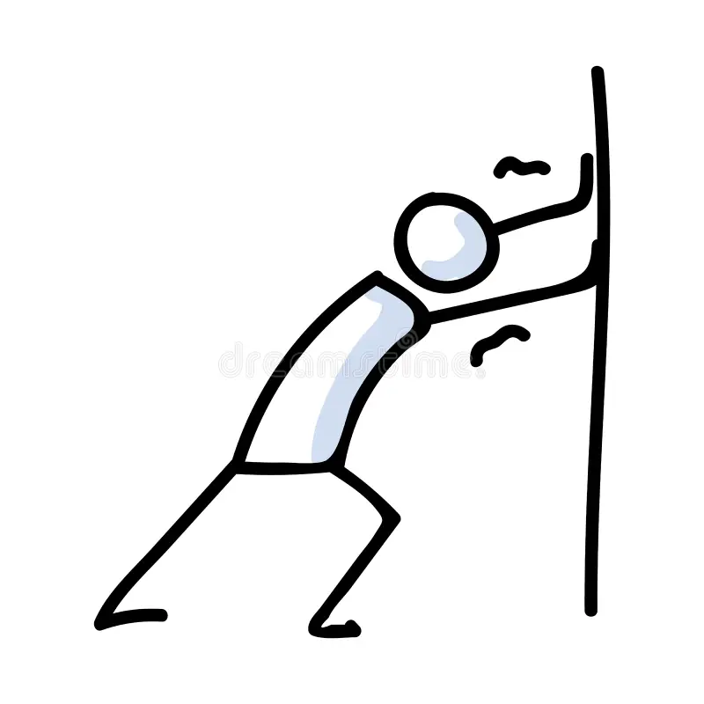

Forces that act parallel to each other are called parallel forces. If they act in the same direction, they are known as like parallel forces (e.g., pushing a cart with both hands). If they act in opposite directions, they are called unlike parallel forces (e.g., turning a bicycle handle with unequal forces).

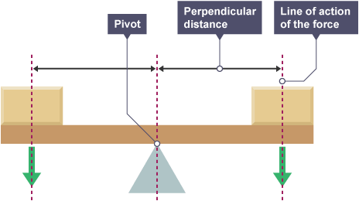

## 4.2 MOMENT OF A FORCE

The moment of a force or torque is the turning effect produced by a force about a pivot or axis of rotation. It is calculated as the product of the force (F) and the perpendicular distance (d) from the axis of rotation to the line of action of the force.

Turning effect produced in a body about a fixed point due to applied force is called moment of force (or torque).

Mathematically: $τ=F×d$

The unit is Newton meter (Nm).

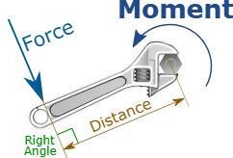

The perpendicular distance d is called the moment arm. A larger moment arm or a larger force will produce a greater torque. Torque can cause clockwise or anticlockwise rotation. By convention, clockwise torque is taken as negative, and anticlockwise torque as positive.

In tools such as wrenches and doors, increasing the moment arm (e.g., longer handle) increases torque with the same force.

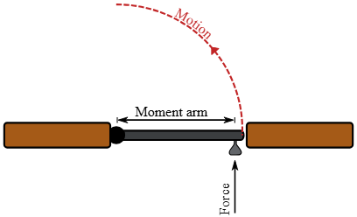

## 4.3 CENTER OF MASS

The center of mass (CM) of a rigid body is the point where its mass appears to be concentrated and distributed equally in all directions. When a force acts through the CM, it produces no rotation. The CM follows a smooth path such as in the case of a thrown hammer.

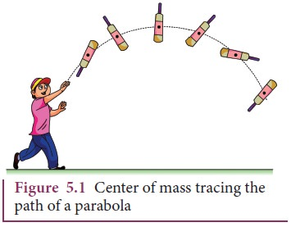

Center of gravity (CG) is the point where the entire weight of a body appears to act. For small objects, CM and CG are the same, but for large or tall objects, gravity varies with height, making them slightly different.

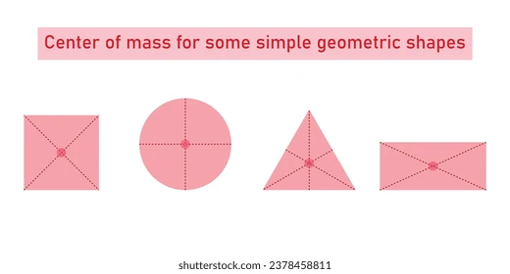

The CM of symmetrical and uniform objects (cube, sphere, cylinder) lies at their geometric center. For irregular objects, the CG can be found by suspending the object from different points and locating the intersection of vertical lines.

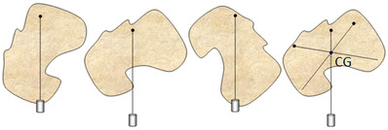

## 4.4 EQUILIBRIUM

Equilibrium is the state in which all forces and torques acting on a body are balanced. A body in equilibrium does not accelerate and remains either at rest or moves with uniform velocity.

**4.4.1 CONDITION OF EQUlLIBRlUM**

First condition of equilibrium: The vector sum of all forces acting on the body must be zero. This ensures that there is no linear acceleration. Mathematically:

$ΣF=0$

$F_{net}=F_{1}+F_{2}+F_{3}+....F_{N}=0$

Second condition of equilibrium: The sum of all torques acting on a body must be zero. This ensures no rotational acceleration. Mathematically:

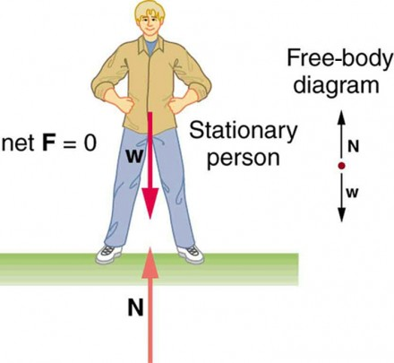

$Στ=0$

$τ_{net}=τ_{1}+τ_{2}+τ_{3}+....τ_{N}=0$

**4.4.2 PRINCIPLE OF MOMENTS**

For an object in equilibrium, the sum of the clockwise moments taken about the pivot must be equal to the sum of anti-clockwise moments taken about the same pivot.

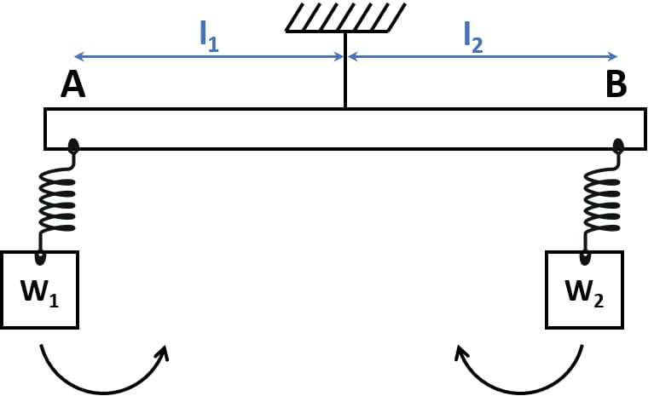

To balance torques or moments of force, the perpendicular distance from the axis of rotation plays an important role.

This means that having less weight (or force), the moment arm should be greater in order to produce the same torque as produced by a greater weight and small moment arm.

**4.4.3 TYPES OF EQUILIBRIUM**

**Static equilibrium:** When a body is at rest under the action of several forces acting together and several torques acting the body is said to be in static equilibrium.

**Dynamic equilibrium:** When a body is moving at uniform velocity under the action of several forces acting together the body is said to be in dynamic equilibrium. It is further divided into two types:

**I. Dynamic Translational Equilibrium:** When a body is moving with uniform linear velocity the body is said to be in dynamic translational equilibrium.

**Dynamic Rotational Equilibrium:** When a body is moving with uniform rotation the body is said to be in dynamic rotational equilibrium.

## 4.5 STABILITY

Stability refers to the ability of a body to return to its original position after being slightly disturbed. This depends on the position of the center of gravity and the size of the base of support.

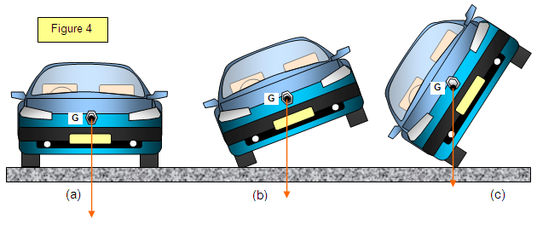

**Stable equilibrium:** When displaced slightly, an object returns to its original position. Its center of mass rises when displaced, creating a restoring moment. Example: a book resting on a table.

**Unstable equilibrium:** When displaced slightly, an object moves further away from its original position. The center of mass lowers upon displacement, increasing the displacement. Example: a pencil balanced on its tip.

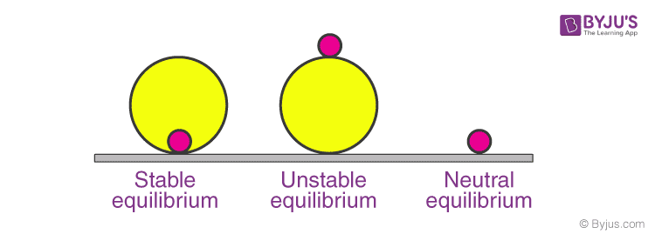

**Neutral equilibrium:** When displaced, the object stays in its new position. The CM neither rises nor falls. Example: a ball on a flat surface.

Stability can be increased by lowering the center of mass or increasing the base area.



When an object is in stable equilibrium , it means that if it is slightly disturbed or tilted, it has a tendency to return to its original position. This is because the gravitational force acting on the object causes it to rotate around the point of support, and the object’s weight acts through its center of mass. As a result, the object naturally realigns itself to maintain its stable equilibrium state.

Once such a toy is shaped like an egg, when it is tilted, the position of the pivot changes because of its round bottom. Therefore, this toy always has a restoring mechanism that brings it back to its vertical position, where the weight is directly above the pivot.

## 4.6 FRICTION

Friction is a force that resists the motion of one surface over another. It acts in the opposite direction of motion and occurs in solids, liquids, and gases. It is a vector quantity with units of newtons (N). Friction always acts in a direction to oppose motion.

**4.6.1 MICROSCOPIC DESCRIPTION OF FRICTION**

Microscopic description: All surfaces are rough at microscopic levels. Irregularities interlock, causing friction. Thus roughness of both surfaces interlock which makes friction.

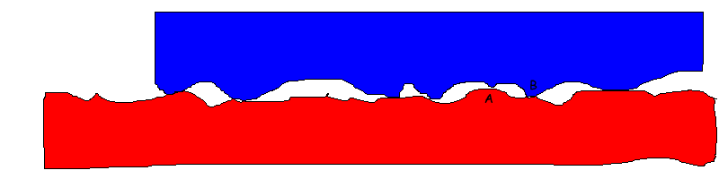

Sliding friction is the resistance created by any two objects when sliding against each other. It is the sliding friction between the brake pads and our bike rims that slows the rolling wheels.

**4.6.2 ADVANTAGES AND DISADVANTAGES OF FRICTION**

Advantages of friction: Walking, driving cars, holding screws and nails.

Disadvantages: Wastage of energy, wear and tear, heating of machine parts.

**4.6.3 METHODS OF REDUCING FRICTION**

Methods of reducing friction: Polishing surfaces, using ball bearings to convert sliding friction to rolling friction, and applying lubricants like oil or grease.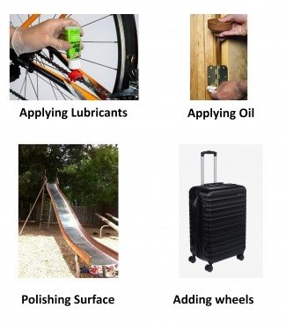

* **By polishing:** If we polish the rough surfaces, they become smooth and friction is reduced.
* **By using Ball Bearing:** This method converts the sliding friction into rolling friction by use of ball bearings.
* **By applying Lubricants (oil or Grease) to surfaces:** Friction of certain liquids is less than that of solid surfaces, therefore, oil or grease is applied between the parts of machinery.

**4.6.4 ROLLING FRICTION:**

If we set a heavy spherical ball, ring or cylinder rolling, it experiences an opposing force called rolling friction. For the same weight, rolling friction is much smaller (even by 2 or 3 orders of magnitude) than static or sliding friction.

Force resisting motion when a body rolls over a surface. It is smaller than sliding friction.

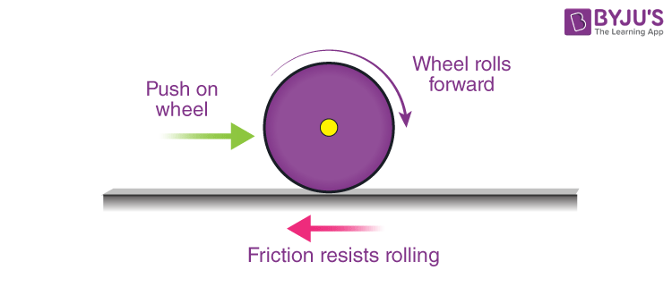

**4.6.5 FLUID FRICTION**

Resistance caused when an object moves through a fluid. Depends on shape, size, fluid properties, and speed. Drag increases with speed and eventually leads to terminal velocity.

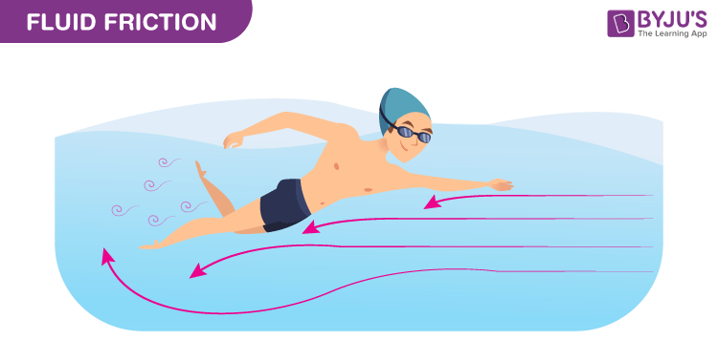

When an object moves through a fluid, the fluid exerts a retarding force that tends to reduce the speed of the object. The moving body exerts a force on the fluid to push it out of the way. By Newton's third law, the fluid pushes back on the body with an equal and opposite force. This retarding force experienced by an object moving through a fluid is called the drag force, which is the result of fluid friction. 

**4.6.6 FRICTIONAL DISSIPATION**

Dissipative force decreases the mechanical energy in a system. Dissipative forces acting on an object always oppose the motion of the object.

Friction converts mechanical energy into heat, as seen in rubbing hands or burning meteors.

## 4.7 CENTRIPETAL FORCE

Centripetal force is the force that keeps an object moving in a circular path. It acts toward the center of the circle. Although speed remains constant, velocity changes due to continuous change in direction.

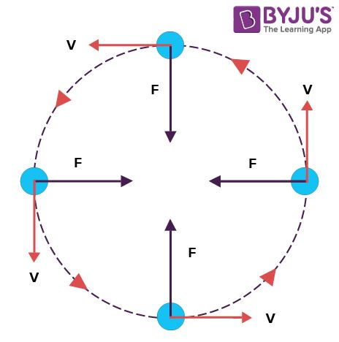

Formula:

$F_{c}=\frac{mv^{2}}{r}$

where m is mass, v is velocity, and r is radius of the circular path. Unit: Newton (N).

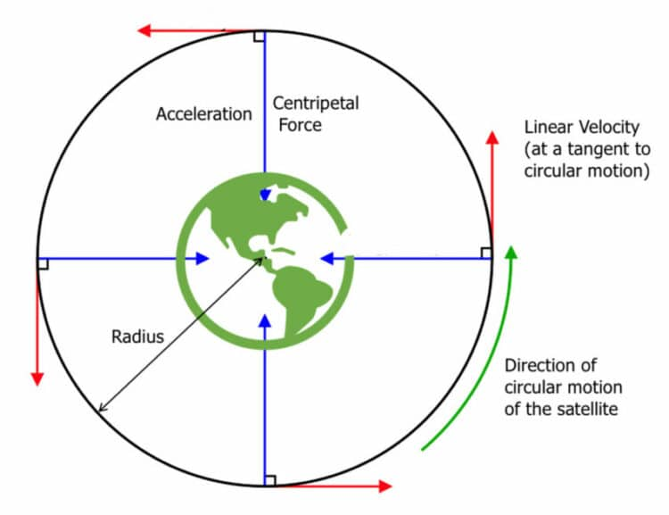

Examples: Tension in a string while swinging a ball, gravitational force keeping the Moon in orbit.

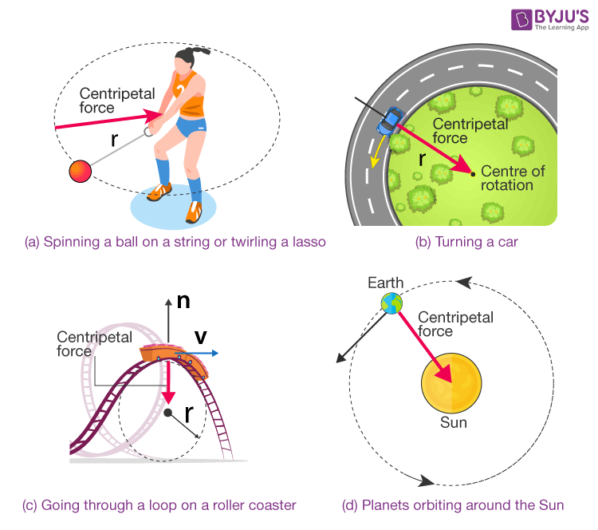

## 4.8 ORBITAL MOTION

Orbital motion refers to the path taken by one object around another due to gravity. Natural satellites include moons and planets. Artificial satellites are placed into orbit using rockets. Satellites are typically put into circular (or nearly circular) orbits.

**4.8.1 AVERAGE ORBITAL SPEED OF SATELLITE**

The orbital speed of the body is the speed at which it orbits around the center of the system. This system is usually around a massive body.

Average orbital speed: $v=\frac{2Πr}{T}$

where r is radius of orbit and T is the orbital period.

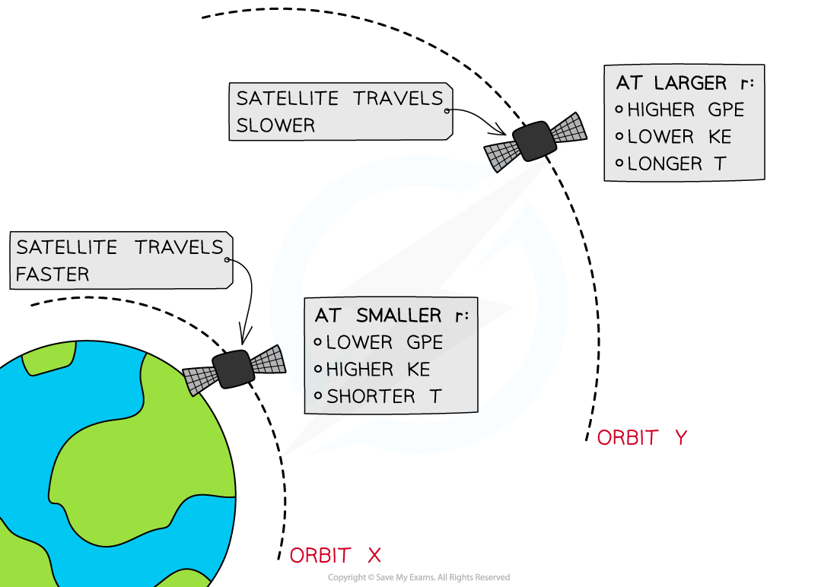

If the speed is too high, the satellite escapes; if too low, it falls back to Earth.

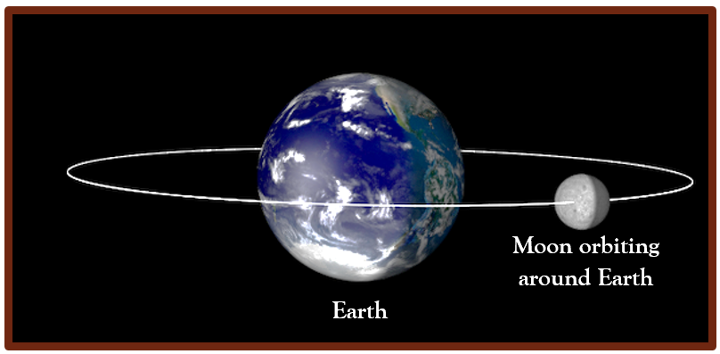

## 4.9 PLANETARY DATA

Our solar system consists of the Sun and objects gravitationally bound to it. This includes eight planets, dwarf planets, moons, asteroids, and comets.

